HSVNA (Historic Sierra Vista Neighborhood Association) SPRING 2022 News!

- Our next general meeting is April 7, 2022 @ 6:00 pm at Woodbridge Park Pavilion.
- Our Annual Garage Sale for is Saturday, June 4, 2022. We will advertise. You manage your own sale.
*NEW this year, anyone can financially donate during the garage sale to help benefit our yearly events!
- Saturday June 18, 2022, City-wide Spring Cleanup Day with Dumpsters!

“Sell what you can. Dump what you can’t!”
Clean out closets, garages and sell it if you can, or you help clean up our neighborhood by dumping it!
Please reach out to neighbors with special needs who might need assistance.

Join us on Saturday, June 18th in making Roseville a cleaner city! We will be bringing 20 ft. dumpsters to the Roseville High School. Residents will be able to bring their junk to this site at no charge. *Proof of Roseville Residency will be verified! Go to the following City link to get information about what are acceptable and unacceptable items to dump.
http://roseville.ca.us/neighborhoodcleanup https://www.roseville.ca.us/cms/One.aspx?portalId=7964922&pageId=18325415

We need volunteers for our Spring Cleanup!
A great way to give back to your community.

What will volunteers do:
Direct traffic. Verify Residency. Check for allowed/prohibited items. Possibly assist with unloading items for special needs neighbors.
A volunteer waiver form will be required of all volunteers. All minors must have a waiver form signed by a parent. Request a form at treasurer@rcona.org
The shifts are: 8:00 – 10:30 a.m., 10:30 – 1:00 p.m., or 1 – 3:30 p.m. If a volunteer would like to work multiple shifts on a day, that would even be better!! We need help! Drinks and Food will be provided. (Donations welcome if you can sponsor our event!)
Roseville High School Volunteers: RCONA Spring Cleanup (signupgenius.com) https://www.signupgenius.com/go/9040545abaa23a02-rcona2

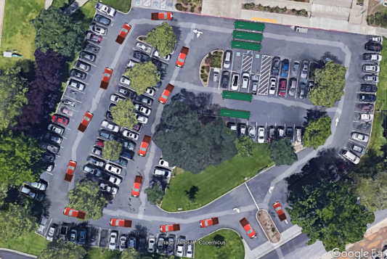
Please contact Glenda Atwood Hay @ Sierravista95678@gmail.com with questions.

